SAILING INSTRUCTIONS
RS Aero Event Vrijbuiter
Organised by G.W.V. De Vrijbuiter
16th October 2022
location: Loosdrechtse Plassen
______________________________________________________________________________________

[DP] denotes a rule for which the penalty is at the discretion of the Protest Committee
[NP] denotes that a breach of this rule will not be grounds for a protest by a boat.
- RULES
1.1 The event is governed by the rules as defined in The Racing Rules of Sailing (RRS) .
1.2 Racing rules will be changed as follows:
RRS:
35, A4, A5, A10
1.3 All competitors and support persons must adhere to the corona rules of the Dutch government. For the rules see https://www.government.nl/topics/coronavirus-covid-19.

1.4 [DP] Competitors and support persons shall comply with any reasonable request from an event official. Failure to comply may be misconduct. - Reasonable actions by event officials to implement COVID-19 guidance, protocols or legislation, even if they later prove to have been unnecessary, are not improper actions or omissions.
2 CHANGES TO SAILING INSTRUCTIONS

2.1 Any change to the sailing instructions will be made 45 minutes before the warning signal for the race upon which it will take effect, except that any change to the race schedule will be mentioned at least 1 hour before the race start upon which it will take effect.

3 COMMUNICATIONS WITH COMPETITORS
3.1 Notices to competitors will be posted on the official notice board located at the race office.

3.2 The race office is located at the hallway of the club house:
G.W.V. De Vrijbuiter
Oud-Loosdrechtsedijk 137
Loosdrecht
4 [DP] CODE OF CONDUCT
4.1 Competitors and support persons shall comply with reasonable requests from race officials.
4.2 Competitors and support persons shall handle any equipment provided by the organizing authority with care, seamanship, in accordance with any instructions for its use and without interfering with its functionality.
5. SIGNALS MADE ASHORE
5.1 Signals made ashore will be displayed on the flagpole at the start-tower.
5.2 When flag AP is displayed ashore, ‘1 minute’ is replaced with ‘not less than 30 minutes’ in the race signal AP.

6 SCHEDULE OF RACES
6.1 Dates of racing:
Date Class RSAero
16-10-2022 racing
6.2 Number of races:
Class Number of races
RS Aero max 5
6.3 The scheduled time of the warning signal for the first race on 16-10-2022 is 10.55 hrs.
6.4 To alert boats that a race or sequence of races will begin soon, an orange flag will be displayed with one sound for at least four minutes before a warning signal is displayed.
6.5 No warning signal will be made after 15.45 hrs.

7 CLASS FLAGS
7.1 Class flags for the RS Aero will be:

W flag

8 RACING AREA
The location of the racing area is Loosdrechtse Plassen. The starting area is defined by area of 50 meters around the starting line.
9 THE COURSES
9.1 The diagram in Attachment A shows the course, including the order in which marks are to be passed, and the side on which each mark is to be left.
10 MARKS
10.1 The marks of the course are orange or yellow inflatable cylindrical buoys.
10.2 The starting line will be between two orange flags on the marks of the start line. The start ship is recognized by a Vrijbuiter flag. The finishing marks are a blue flag on the finishing ship and an orange flag on the port end of the finishing line.

11 AREAS THAT ARE OBSTRUCTIONS
There are no areas designated as obstructions.

12 THE START
12.1 The starting marks are an orange flag on the starting ship and an Buoy with orange flag at the port end of the starting line.
12.2 A boat that does not start within 5 minutes after her starting signal will be scored ‘Did Not Start’ without a hearing. This changes RRS A5.1 and A5.2.
13 CHANGE OF THE NEXT LEG OF THE COURSE
13.1 To change the next leg of the course, the race committee will move the original mark or the finishing line to a new position. A change of course shall not be signalled.
14 THE FINISH
The finishing line will be between 2 staffs displaying a blue flag on the starboard finish mark and an orange flag on the port finish marks.
15 SCORING

15.1 Handicap racing scores shall be run using the RYA Portsmouth Yardstick Scheme:
RS Aero 5 1136
RS Aero 6 1100
RS Aero 7 1065
RS Aero 9 1014
16 TIME LIMITS AND TARGET TIMES

16.1 The Mark 1 Time Limit and the Finishing Window are shown (in minutes) in the table below.
Class Mark 1 Time limit Finishing Window Targe time race
RS Aero 5,7,6,9 20 min 15 min 45 min
16.2 If no boat has passed Mark 1 within the Mark 1 time limit the race will be abandoned.
16.3 The Finishing Window is the time for boats to finish after the first boat sails the course and finishes. Boats failing to finish within the Finishing Window, and not subsequently retiring, penalized or given redress, will be scored Time Limit Expired (TLE) without a hearing. A boat scored TLE shall be scored points for the finishing place one more than the points scored by the last boat that finished within the Finishing Window. This changes RRS 35, A5.1, A5.2 and A10.
16.4 Failure to meet the target time will not be grounds for redress. This changes RRS 62.1(a).
17 PROTESTS AND REQUESTS FOR REDRESS
17.1 For each class, the protest time limit is 45 minutes after the last boat in that class finished the last race of the day or the race committee signals no more racing today, whichever is later. The time will be posted on the official notice board.
17.2 Hearing request forms are available at the race office.
17.3 Notices will be posted within 30 minutes after the protest time limit to inform competitors of hearings in which they are parties or named as witnesses. Hearings will be held in the jury room, located near the race office, beginning at the time posted.
18 [NP][DP] SAFETY REGULATIONS
18.1 [DP] A boat that retires from a race shall notify the race committee at the first reasonable opportunity.

19 REPLACEMENT OF CREW OR EQUIPMENT
19.1 Substitution of competitors will not be allowed without prior written approval of the race committee. Replacement of the responsible person is not allowed.
20 SPARE

21 Charter Boats
Some charter boats are made available by RS, a charter agreement needs to be signed by applicable users indicating boats will be handled with care and good seamanship. An amount of 150€ will be treated as own risk in case of damage.
22 OFFICIAL VESSELS
Official vessels will be identified as follows:
- White flag with green text V6
23 SPARE
24 TRASH DISPOSAL
Trash may be placed aboard official or support persons boats.
25 ORGANISATION
The race officer is: Bart Van Bazel
The chairman of the protest committee is: TBD

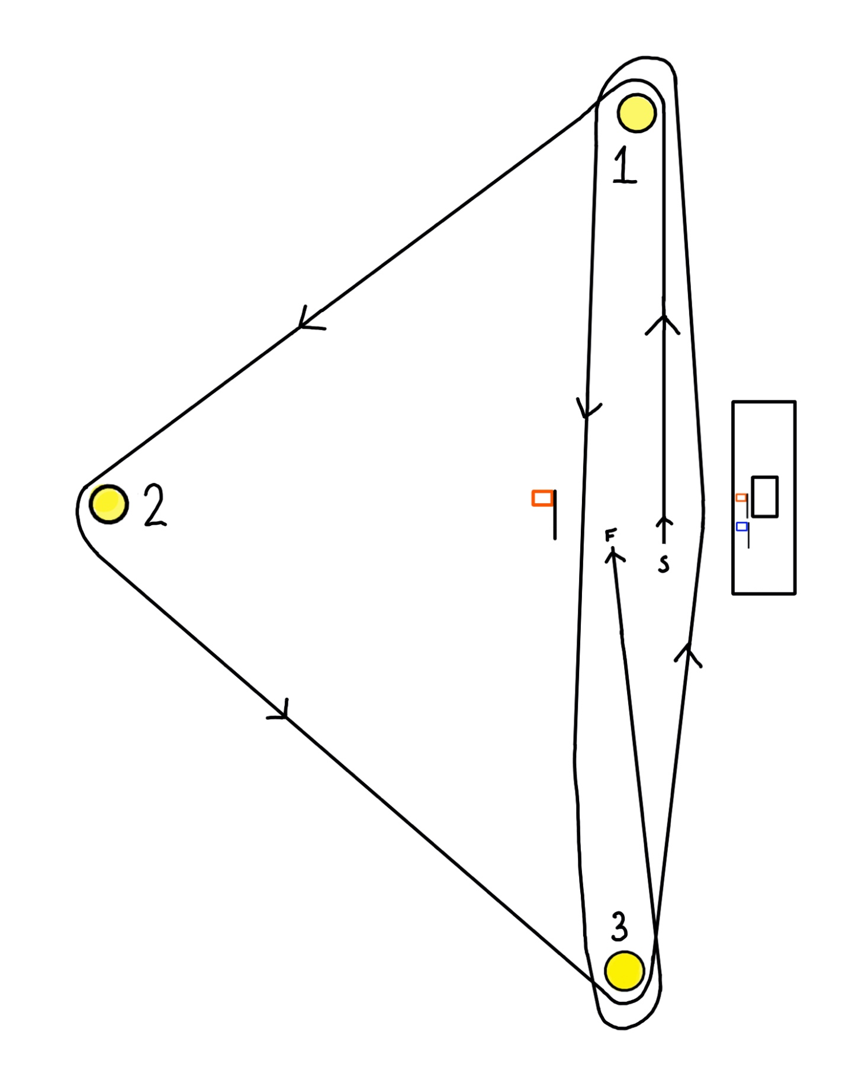
ATTACHMENT A – THE COURSE

Triangle Course

Start

1 – 2 – 3 – 1 – 3

Finish

